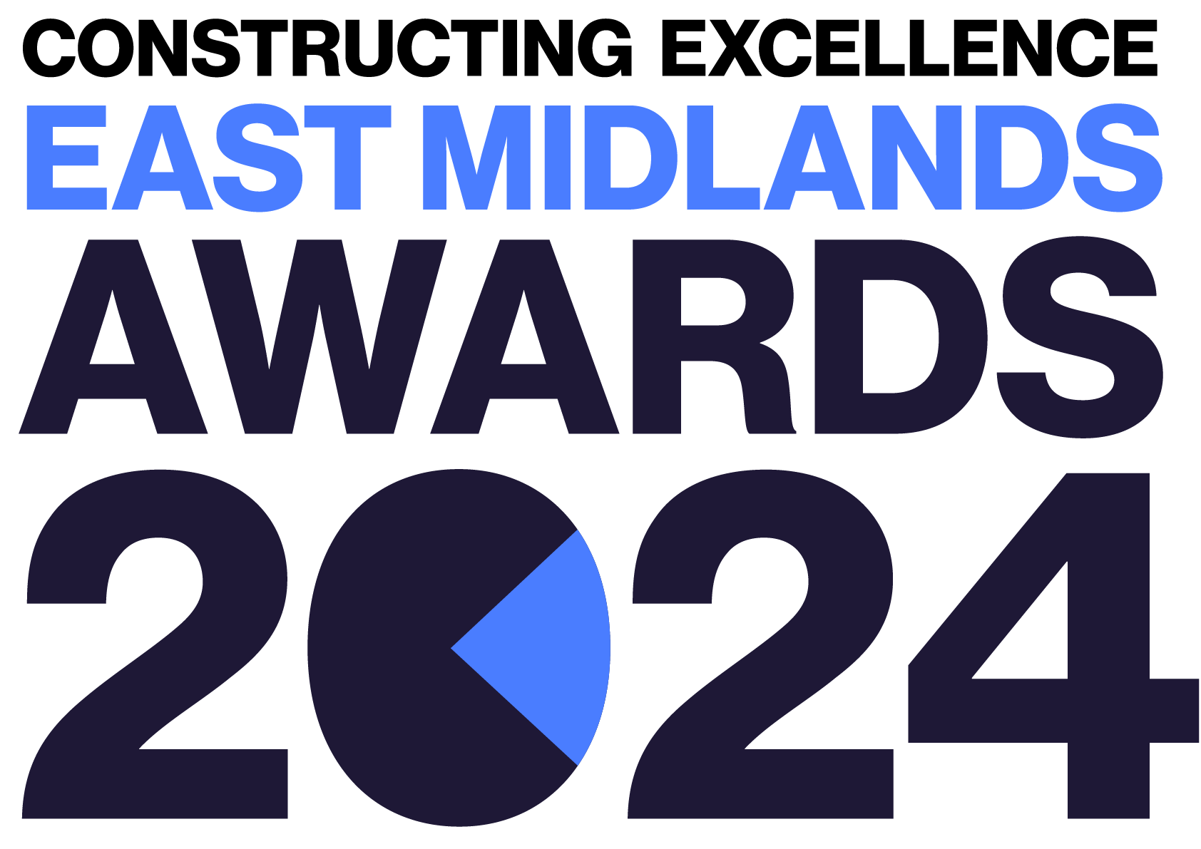
SME of the Year
Constructing Excellence East Midlands Awards Entry Form

Category Description

The UK government definition of Small to Medium Enterprises encompasses; micro (less than 10 employees and an annual turnover under €2 million), small (less than 50 employees and an annual turnover under €10 million) and medium-sized (less than 250 employees and an annual turnover under €50 million) businesses.

SMEs are a core part of the supply chain and are the backbone of the construction industry. Constructing Excellence are seeking to showcase examples of organisations that embody best practise. Applicants should model the Constructing Excellence principles of procurement, innovation, collaboration, culture/people, productivity, client satisfaction, HS&W, Digital.

Judges are looking for organisations that demonstrate:
- Continual professional development i.e. training, developing competence, pathways to progression, leaderships & successor development.
- A culture of inclusivity, psychological safety and mental health support.
- A safety-first culture, with the correct culture, systems and processes in place.
- Good staff retention and team satisfaction - recognised as being a good place to work.
- Commitment to addressing the skills shortage - actively encouraging diverse new entrants to the industry and nurturing emerging talent.
- Financial sustainability with a future focus and strategy.
- Engagement with the community, providing support and getting involved with events and initiatives.
- The team/company MUST be based within the East Midlands.

Entry Information:

To be included in your submission:

☐ Entry guidelines checked and adhered to – https://constructingexcellence.org.uk/awards-guidance/
☐ Completed entry form – low resolution images can be embedded to support your entry.
☐ Logos – for all key parties that should be recognised for the award (original .eps files).
☐ High resolution images (print quality) – up to 5 jpg files to be shared separately, not embedded.

Information included in your awards entry may be used by Constructing Excellence for Awards marketing purposes if the submission is successful.

Submissions must be received by: 19th April 2024

Completed entry forms and images should be sent to: eastawards@cemidlands.org

Good luck!
The Constructing Excellence Team
SME of the Year
Constructing Excellence East Midlands Awards Entry Form Submission Details

Entry name
Region

*Maximum 70 characters (with spaces). This name will be on the award if successful*

Applicant’s contact details:

Name
Organisation
Email
Telephone
Address
Postcode
Type of organisation

Number of staff
Company turnover

IMPORTANT: Logos – please supply HIGH QUALITY .eps or .jpeg logo files for all organisations mentioned.
These logos will be etched onto the glass trophies presented to winners.

SME of the Year
Constructing Excellence Awards Entry Form Your Submission

- Provide a short overview of the company (max. 250 words)

* Please provide a clear summary of the key aspects of your submission. This section will be used for marketing purposes. A clear and succinct answer ensures we showcase your project effectively. *

Guidance questions: Briefly describe the company- what makes this submission a winning entry? What are the three key facts that make this organisation stand out?
Three Winning Facts:
1.
2.
3.

- What is your headline strategy? How have you systematically engaged with and developed best practice across the organisation?
(max. 250 words)

- How have you invested in your employees/ business? How do you support employees' professional development? What have you done to develop a positive culture? How do you support inclusion and diversity within the organisation? (max. 250 words)

- How have you improved your productivity, customer satisfaction and/or wider sustainability?
(max. 250 words)

- How do you work with your local community? What is your strategy and demonstrable progress to actively improve your impact on the environment and community? (max. 250 words)

- How have you engaged with your employees and project partners to add value to projects?
(max. 250 words)

- What development and performance targets do you have and what is your performance against them?
(max. 250 words)

