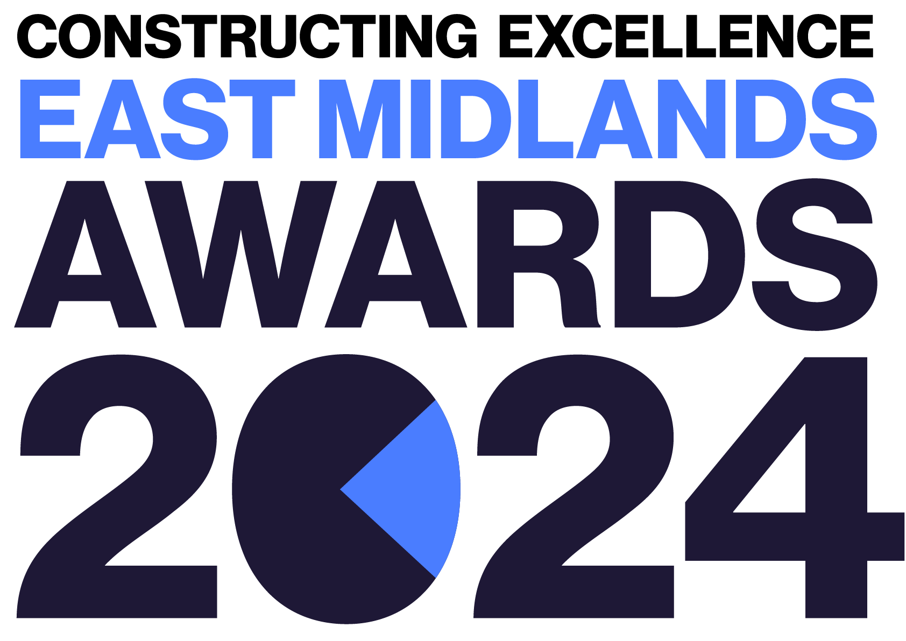
Regeneration & Retrofit
Constructing Excellence East Midlands Awards Entry Form

Category Description

The Regeneration and Refit Award aims to highlight projects or programmes that apply the Constructing Excellence principles to deliver better outcomes for an existing asset, which may include historic/heritage sites. These principles include procurement, innovation, collaboration, culture/people, productivity, client satisfaction, HS&W and Digital. Applicants must demonstrate how they achieve improved outcomes against these principles.

Judges are looking for projects or programmes that demonstrate:
- Successful delivery of client / community goals and expectations.
- Improved performance of the existing asset.
- Collaborative practices within the delivery process.
- Use of digital through the project.
- Employment of innovative techniques.
- Measured impact of the solutions and end result.
- The project MUST be based within the East Midlands.

Entry Information:

To be included in your submission:

- ☐ Entry guidelines checked and adhered to – https://constructingexcellence.org.uk/awards-guidance/
- ☐ Completed entry form – low resolution images can be embedded to support your entry.
- ☐ Logos – for all key parties that should be recognised for the award (original .eps files).
- ☐ High resolution images (print quality) – up to 5 jpg files to be shared separately, not embedded.

Information included in your awards entry may be used by Constructing Excellence for Awards marketing purposes if the submission is successful.

Submissions must be received by: 19th April 2024

Completed entry forms and images should be sent to: eastawards@cemidlands.org

Good luck!
The Constructing Excellence Team

Regeneration & Retrofit
Constructing Excellence East Midlands Awards Entry Form Submission Details

Entry name
Region

*Maximum 70 characters (with spaces). This name will be on the award if successful*

Applicant’s contact details:

Name
Organisation
Email
Telephone
Address
Postcode

Organisations to be credited:

Please list the client related to this submission:

Client
Contact name
Email

Please list all organisations that should be credited in relation to this submission:

Organisation
Contact name
Email

Organisation
Contact name
Email

Organisation
Contact name
Email

Organisation
Contact name
Email

Organisation
Contact name
Email

Organisation
Contact name
Email

IMPORTANT: Logos – please supply HIGH QUALITY .eps or .jpeg logo files for all organisations mentioned.
These logos will be etched onto the glass trophies presented to winners.
Regeneration & Retrofit
Constructing Excellence Awards Entry Form Project Details

Project name
Project location
Project timescales or phase | Start date: | End date:
Project contract value
Type of work
(e.g. new build, refurb)
Type of client
(e.g. housing association, developer, gov. department)
Construction product
(e.g. school, housing, road)
Approx. m²

Regeneration & Retrofit
Constructing Excellence Awards Entry Form Your Submission

- Provide a short overview (max. 250 words)

* Please provide a clear summary of the key aspects of your submission. This section will be used for marketing purposes. A clear and succinct answer ensures we showcase your project effectively. *

Guidance questions: Briefly describe the project/programme- what makes this submission a winning entry? What are the three key facts that make this work stand out?
Three Winning Facts:
1.
2.
3.

- Describe the challenge that the existing asset presented to the team. Were there listed building statuses, existing occupants, space considerations, dangerous materials or structures, unsustainable performances etc.? (max. 250 words)

- How did you approach the project? How did you balance different considerations to come up with the optimum strategy? (max. 250 words)

- What performance improvement was achieved? How was performance measured? Were there any trade-offs? (max. 250 words)

- What tools and techniques did you use? How did you empower the team? What technologies did you use?
(max. 250 words)

- What unforeseen challenges did you face during the project and how did you overcome these?
(max. 250 words)

- What was the outcome? How did the client, community and other stakeholders view the project? How do you intend to build on the lessons learnt from this project? How were lessons learned shared within the project team and wider sector? (max. 250 words)

