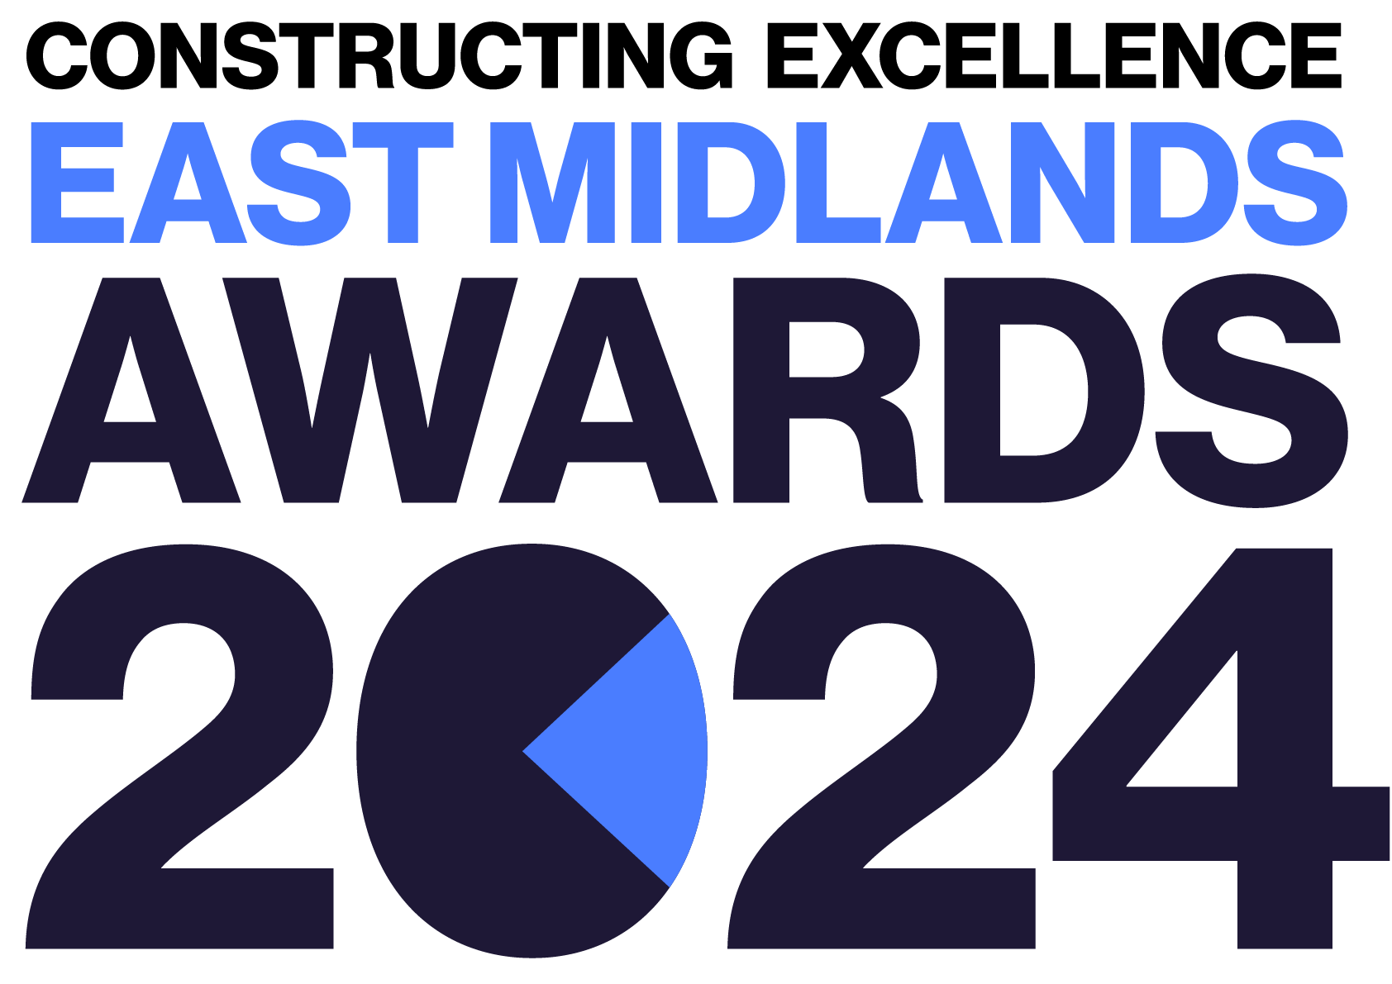
People & Culture
Constructing Excellence East Midlands Awards Entry Form

Category Description

“Our people are our greatest asset” - so attracting, motivating, supporting, developing and retaining the most diverse of human talent to our organisations and the sector is critical to ensure we totally understand and meet our customers' and wider communities’ needs. Strong constructive cultures, effective leadership, health & wellbeing, and psychological safety at every level are vital to ensuring we positively challenge and continuously improve, as is Equality, Diversity & Inclusion and ensuring functional competence through progression pathways and continuing professional development.

Judges are looking for organisations, projects or initiatives that demonstrate:
- Clear strategies.
- Effective implementation of plans.
- Clear evidence of success. Measures are likely to include staff motivation scores and retention data, time and cost invested in people development plans (in-house activities, external programmes or other) at all levels of the organisation or project.
- Community engagement activity that attracts the most talented people to our sector’s diverse roles.
- The team MUST be based within the East Midlands.

Entry Information:

To be included in your submission:

- ☐ Entry guidelines checked and adhered to – https://constructingexcellence.org.uk/awards-guidance/
- ☐ Completed entry form – low resolution images can be embedded to support your entry.
- ☐ Logos – for all key parties that should be recognised for the award (original .eps files).
- ☐ High resolution images (print quality) – up to 5 jpg files to be shared separately, not embedded.

Information included in your awards entry may be used by Constructing Excellence for Awards marketing purposes if the submission is successful.

Submissions must be received by: 19th April 2024

Completed entry forms and images should be sent to: eastawards@cemidlands.org

Good luck!
The Constructing Excellence Team

People & Culture
Constructing Excellence East Midlands Awards Entry Form Submission Details

Entry name
Region

*Maximum 70 characters (with spaces). The name will be on the award if successful*

Applicant’s contact details:

Name
Organisation
Email
Telephone
Address
Postcode
Type of organisation

Number of staff
Company turnover

IMPORTANT: Logos – please supply HIGH QUALITY .eps or .jpeg logo files for all organisations mentioned.
These logos will be etched onto the glass trophies presented to winners.

People & Culture
Constructing Excellence Awards Entry Form Your Submission

- Provide a short overview (max. 250 words)

* Please provide a clear summary of the key aspects of your submission. This section will be used for marketing purposes. A clear and succinct answer ensures we showcase your project effectively. *

Guidance questions: Briefly describe the project/ organisation- what makes this submission a winning entry? What are the three key facts that make this work stand out?
Three Winning Facts:
1.
2.
3.

- How was talent acquisition and retention tackled? What were the most successful efforts to inform, inspire and recruit the most suitable, talented and diverse workforce? How was talent best retained within the organisation and to what effect/benefit? (max. 250 words)

- How was structured training and development ensured? What systems have been put in place to ensure everyone in the team has a suitable clear visible development pathway and makes tracked progress? What about structured coaching/mentoring?
(max. 250 words)

- How has a positive culture been developed? How would you describe the core culture within the project or organisation? What specifically has been done to develop the culture to ensure effective leadership, collaboration, customer focus, health/safety/wellbeing, innovation and/or sustainability? (max. 250 words)

- What strategies have been employed to drive diversity? What has been done to inform, inspire, recruit and retain the most appropriately equal, diverse and inclusive workforce/team to inform and deliver outstanding facilities, customer satisfaction and sustainability? What impact has this had and how has that been measured (and ideally benchmarked)? (max. 250 words)

- How is performance driven? What culture and mechanisms have been introduced to agree ambitious but achievable goals, to drive innovation and increase productivity rates? How is progress measured and reported? How are achievements rewarded to motivate further action? (max. 250 words)

- How has wider change been encouraged? What has been done to inform other organisations (clients, suppliers or wider sector) about your approach and successes? Do you actively work with other organisations to accelerate/improve collective progress, if so, how? (max. 250 words)

- What three elements would you prioritise to best ensure organisations have the best possible People and Culture? Please briefly explain why? (max. 250 words)
1.

2.

3.

