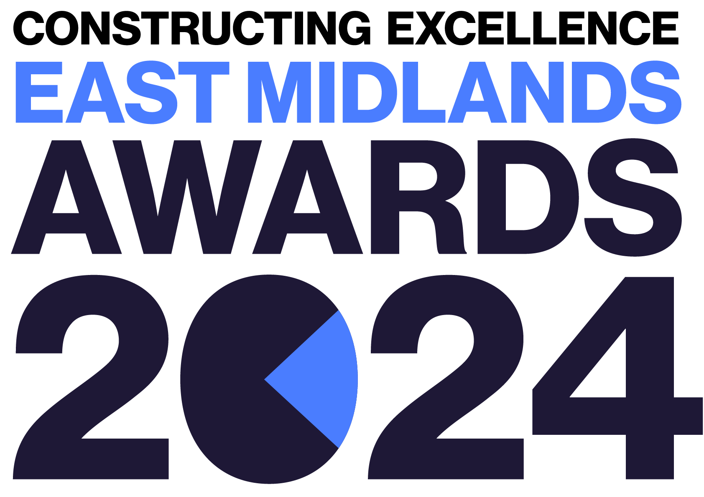
Integration & Collaborative Working
Constructing Excellence East Midlands Awards Entry Form

Category Description

Integration and collaborative working are key to overcoming challenges, managing risk and delivering better outcomes. We are looking for projects and practices that exemplify this approach with evidence of how all parties have been engaged, from clients to contractors and all across the supply chain. Applicants must demonstrate the benefits that have been achieved through a collaborative and integrated working.

Judges are looking for projects or initiatives that demonstrate:
- Better decision making through effective collaboration.
- Use of collaboration to overcome challenges and manage risk.
- Use of collaborative delivery models.
- Early supply chain involvement.
- Clear supply chain strategy and good supply chain management.
- Fair supply chain practices.
- Prompt payments.
- The team MUST be based within the East Midlands.

Entry Information:

To be included in your submission:

- ☐ Entry guidelines checked and adhered to – https://constructingexcellence.org.uk/awards-guidance/
- ☐ Completed entry form – low resolution images can be embedded to support your entry.
- ☐ Logos – for all key parties that should be recognised for the award (original .eps files).
- ☐ High resolution images (print quality) – up to 5 jpg files to be shared separately, not embedded.

Information included in your awards entry may be used by Constructing Excellence for Awards marketing purposes if the submission is successful.

Submissions must be received by: 19th April 2024

Completed entry forms and images should be sent to: eastawards@cemidlands.org

Good luck!
The Constructing Excellence Team

Integration & Collaborative Working
Constructing Excellence East Midlands Awards Entry Form Submission Details

Entry name
Region

*Maximum 70 characters (with spaces). This name will be on the award if successful*

Applicant’s contact details:

Name
Organisation
Email
Telephone
Address
Postcode

Organisations to be credited:

Please list the client related to this submission:

Client
Contact name
Email

Please list all organisations that should be credited in relation to this submission:

Organisation
Contact name
Email

Organisation
Contact name
Email

Organisation
Contact name
Email

Organisation
Contact name
Email

Organisation
Contact name
Email

Organisation
Contact name
Email

IMPORTANT: Logos – please supply HIGH QUALITY .eps or .jpeg logo files for all organisations mentioned.
These logos will be etched onto the glass trophies presented to winners.
Integration & Collaborative Working
Constructing Excellence Awards Entry Form Project Details

*Complete Section 1 if your submission is a project or Section 2 for an Initiative or Organisation

Project name
Project location
Project timescales or phase | Start date: | End date:
Project contract value
Type of work
(e.g. new build, refurb)
Type of client
(e.g. housing association, developer, gov. department)
Construction product
(e.g. school, housing, road)
Approx. m²

Organisation / Initiative Details

Organisation / initiative name
Location
Type of organisation (e.g. housing association, developer, government department, contractor, consultant)
Number of staff
Company turnover

Integration & Collaborative Working
Constructing Excellence Awards Entry Form Your Submission

- Provide a short overview (max. 250 words)

* Please provide a clear summary of the key aspects of your submission. This section will be used for marketing purposes. A clear and succinct answer ensures we showcase your project effectively. *

Guidance questions: Briefly describe the project or initiative - what makes this submission a winning entry? What are the three key facts that make this work stand out?
Three Winning Facts:
1.
2.
3.

- How was early involvement of the supply chain ensured? (max. 250 words)

- What procurement strategy was used and how did this help to deliver value? How was it ensured that procurement was made on best value, not lowest price? (max. 250 words)

- How did the contract used encourage & deliver a collaborative culture? How was a common vision achieved? How did the team ensure understanding of the goals and outcomes to enable alignment?
(max. 250 words)

- What tools and processes were used? (max. 250 words)

- How was the performance of the supply chain measured? How was this fed back? How was continuous improvement maintained? (max. 250 words)

- Were any long-standing relationships already in place beforehand? What benefits did this provide? How was the development of 'new' relationships supported? What outcomes have been achieved via these relationships? (max. 250 words)

