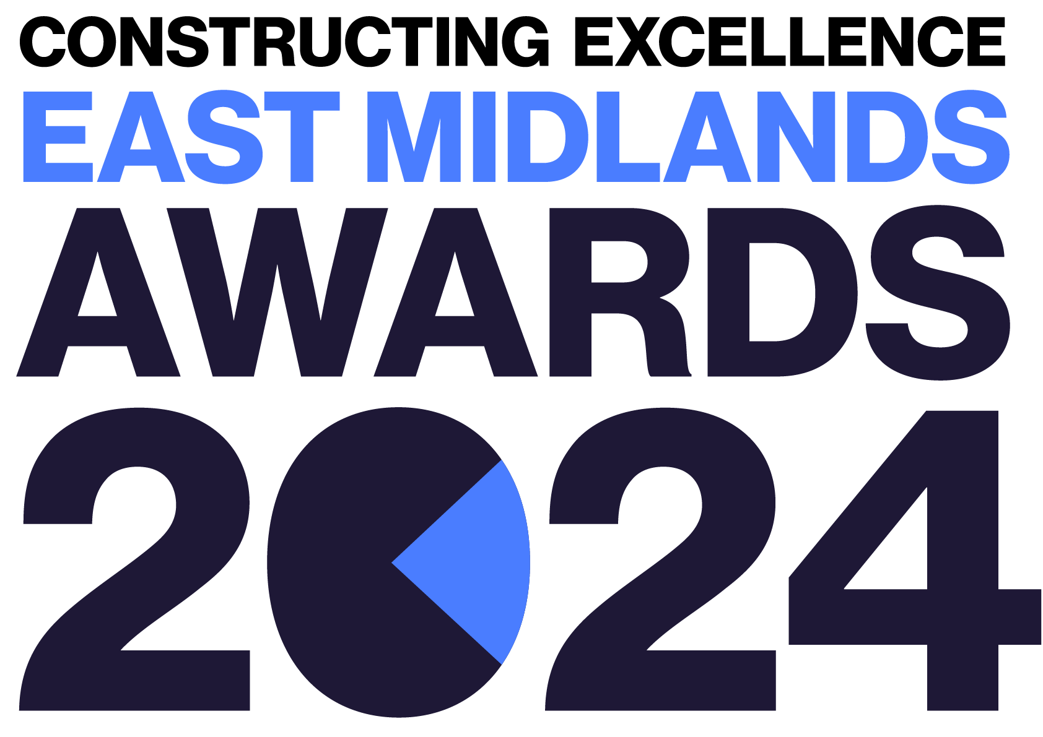
Innovation
Constructing Excellence East Midlands Awards Entry Form

Category Description

Innovation more than invention is critical to every sector to deliver outstanding results, break through productivity barriers and address our customers, communities and global needs. Our sector solves problems every day, yet rarely are we systemic in our organisations and projects to drive and embed a culture for innovation in our teams or our supply chain partners.

Successful applicants will demonstrate how they foster a culture for innovation and systematically solve quantified problems with new or repurposed tools and techniques used by other sectors or organisations - to deliver quantified better productivity, profitability, sustainability or any other critical element with the use of an innovative product or approach that can/will be repeatedly used within the organisation or wider sector.

Judges are looking for organisations, projects or initiatives that demonstrate:
- Proven improvement in outcome through innovation.
- Clear ambitions, strategies and action plans which intentionally drive positive change.
- Progressive procurement policies to enable and reward supply chain innovation.
- Outreach programmes that actively seek out different approaches from very different sectors with the intent to find better solutions or processes.
- Clear evidence of action taken, and results achieved, that show a positive significant step change in performance compared to previous years and most others in the sector.
- The team MUST be based within the East Midlands.

Entry Information:

To be included in your submission:

- ☐ Entry guidelines checked and adhered to – https://constructingexcellence.org.uk/awards-guidance/
- ☐ Completed entry form – low resolution images can be embedded to support your entry.
- ☐ Logos – for all key parties that should be recognised for the award (original .eps files).
- ☐ High resolution images (print quality) – up to 5 jpg files to be shared separately, not embedded.

Information included in your awards entry may be used by Constructing Excellence for Awards marketing purposes if the submission is successful.

Submissions must be received by: 19th April 2024

Completed entry forms and images should be sent to: eastawards@cemidlands.org

Good luck!
The Constructing Excellence Team

Innovation
Constructing Excellence East Midlands Awards Entry Form Submission Details

Entry name
Region

*Maximum 70 characters (with spaces). This name will be on the award if successful*

Applicant’s contact details:

Name
Organisation
Email
Telephone
Address
Postcode

Organisations to be credited:

Please list the client related to this submission:

Client
Contact name
Email

Please list all organisations that should be credited in relation to this submission:

Organisation
Contact name
Email

Organisation
Contact name
Email

Organisation
Contact name
Email

Organisation
Contact name
Email

Organisation
Contact name
Email

Organisation
Contact name
Email

IMPORTANT: Logos – please supply HIGH QUALITY .eps or .jpeg logo files for all organisations mentioned.
These logos will be etched onto the glass trophies presented to winners.
Innovation
Constructing Excellence Awards Entry Form Project Details

*Complete Section 1 if your submission is a project or Section 2 for an Initiative or Organisation

Project name
Project location
Project timescales or phase | Start date: | End date:
Project contract value
Type of work
(e.g. new build, refurb)
Type of client
(e.g. housing association, developer, gov. department)
Construction product
(e.g. school, housing, road)
Approx. m²

Organisation / Initiative Details

Organisation / initiative name
Location
Type of organisation (e.g. housing association, developer, government department, contractor, consultant)
Number of staff
Company turnover

Innovation
Constructing Excellence Awards Entry Form Your Submission

- Provide a short overview (max. 250 words)

* Please provide a clear summary of the key aspects of your submission. This section will be used for marketing purposes. A clear and succinct answer ensures we showcase your project effectively. *

Guidance questions: Briefly describe the organisation/project with specific reference to its innovations, where possible benchmarking performance against relevant others.
What makes this submission a winning entry? What are the three key facts that make this work stand out?
Three Winning Facts:
1.
2.
3.

- How did the organisation/project identify credible opportunities for innovation? How did it prioritise those opportunities/issues to address and how did it prioritise resources? What research was done to define the issue and how did it identify possible existing solutions in other sectors/organisations? What strategy/ approach was most effective, why? (max. 250 words)

- What has been your most successful innovation? What factors made it successful? What impact has it already had and what estimates (if any) have been made on the wider benefits to the organisation or sector, if rolled out widely?
(max. 250 words)

- What approach does your organisation/project take to actively seek radically different mindsets or approaches? Does it deliberately seek conversations with other organisations or sectors for inspiration or appropriate solutions? (max. 250 words)

- Did your organisation/project intentionally capture and promote the innovation to other parts of the organisation, project partners or the wider sector? What approach was used to capture and communicate the innovation? What audience was targeted? What response was seen? (max. 250 words)

- What strategy (if any) did you use to systemise or embed the innovation such that it becomes ‘business as usual’ (where appropriate) across the organisation or project partners? What training/support was needed? (max. 250 words)

- Was innovation intentionally procured, if so why and how? Please summarise what approach, if any, was taken to intentionally procure for innovation. How were headline rewards and risks shared? What response did you get from others when procuring for innovative solutions? (max. 250 words)

- How was the innovation funded? What business case, if any, was created to secure investment from the organisation or third parties? Did you use funding mechanisms such as Innovate UK, grants, R&D Tax Credits, etc? (max. 250 words)

