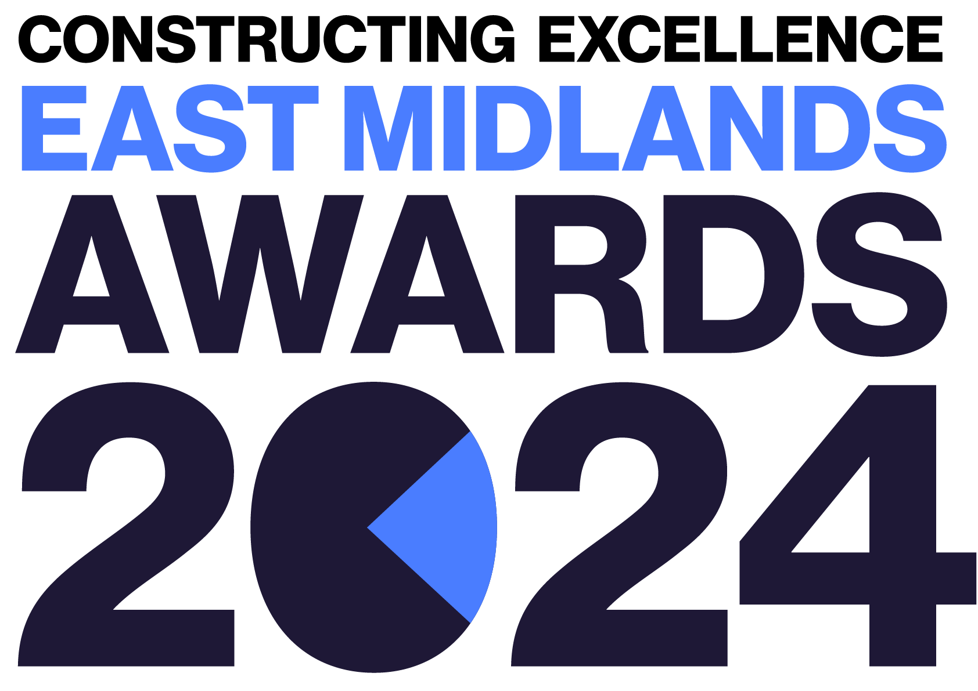
G4C Future Leader
Constructing Excellence East Midlands Awards Entry Form

Category Description

Generation 4 Change (G4C) is the young professional voice of the UK built environment industry and a driving force for change. The Future Leader Award celebrates the younger generation of construction and seeks to showcase the hard work and leadership of these up-and-coming professionals. This should be a person with less than ten years of experience in the industry (typically less than 30 years of age).

Judges are looking for entries that demonstrate:
- Active engagement within the construction industry.
- A positive impact on their peers, their organisation and the wider industry.
- A proven track record of driving change- how is the individual is pushing boundaries and shaping construction?
- Examples of strong leadership characteristics- inspirational, influential, collaborative and visionary.
- A clear focus for the future, both within their own career and development and for the industry as a whole.
- The individual MUST be based within the East Midlands.

Entry Information:

To be included in your submission:

- ☐ Entry guidelines checked and adhered to – https://constructingexcellence.org.uk/awards-guidance/
- ☐ Completed entry form – low resolution images can be embedded to support your entry.
- ☐ Logos – for all key parties that should be recognised for the award (original .eps files).
- ☐ High resolution images (print quality) – up to 5 jpg files to be shared separately, not embedded.

Information included in your awards entry may be used by Constructing Excellence for Awards marketing purposes if the submission is successful.

Submissions must be received by: 19th April 2024

Completed entry forms and images should be sent to: eastawards@cemidlands.org

Good luck!
The Constructing Excellence Team

G4C Future Leader
Constructing Excellence East Midlands Awards Entry Form Individual’s Details

Is your entry? | a direct entry ☐ | a nomination ☐
Region

Please confirm the individual is under 30 OR in the first 10 years of their career | ☐

Main contact’s details:

Name
Organisation
Email
Telephone
Address
Postcode

Nominee’s details:

Name
Position
Current Employer
Type of Organisation

IMPORTANT: Logos – please supply HIGH QUALITY .eps or .jpeg logo files for all organisations mentioned.
These logos will be etched onto the glass trophies presented to winners.

G4C Future Leader
Constructing Excellence Awards Entry Form Your Submission

- Provide a short overview (max. 250 words)

* Please provide a clear summary of the key aspects of your submission. This section will be used for marketing purposes. A clear and succinct answer ensures we showcase your project effectively. *

Guidance questions: Briefly describe the individual- what makes them deserving of the G4C Future Leader Award? What are the three key facts that make this individual stand out?
Three Winning Facts:
1.
2.
3.

- What leadership attributes does the individual display? How do they use their leadership skills to influence others? How has the individual’s performance as a champion of change influenced wider industry challenges i.e. skills shortages, climate change? (max. 250 words)

- How does the individual demonstrate collaborative approaches/strategies? How do they build trust and open relationships with team members and stakeholders across organisation boundaries? How do they collaboratively approach problem solving and the delivery of outcomes? (max. 250 words)

- How does the individual approach innovation? How does the individual’s creativity and ability to think differently support innovation? How do they demonstrably generate ideas, gain buy-in and see them through to implementation? What benefits have been achieved as a result? (max. 250 words)

- What impact has the individual had on sustainability, be it economic, social and/or environmental? What has the individual done to drive positive change and tangible outcomes for their organisation, community and environment? (max. 250 words)

- How has the individual impacted the future of the industry? What sustained change have they delivered and to what benefit? What is their legacy to the industry? (max. 250 words)

