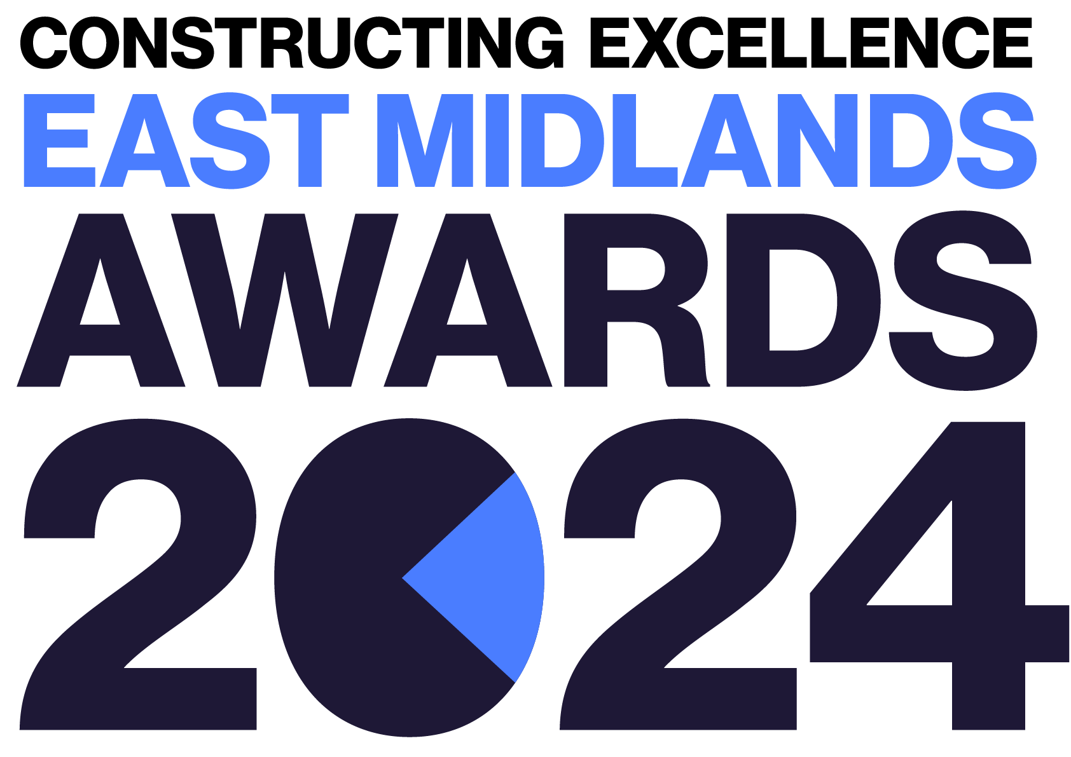
Client of the Year
Constructing Excellence East Midlands Awards Entry Form

Category Description

Construction clients have an important role to play in transforming the way the industry operates. How and when projects come to market significantly impacts the ability of the construction industry to provide innovative, whole life value-for-money solutions.

We are looking for a construction client that has been actively involved in delivering the construction programme and developed strategies for encouraging and rewarding excellence. It goes without saying we expect a culture of collaboration and transparency to be at the heart of how the client operates and empowers the wider team.

Judges are looking for clients that demonstrate:
- Effective leadership
- Fair and prompt payment to all involved (at every level)
- A drive for continuous improvement.
- Commitment to building with the future in mind.
- Effective communication.
- A procurement strategy that puts fairness and transparency at its heart.
- Decision-making based on quality rather than price.
- Support those involved to bring their best ideas and enable collaboration on every level.
- The Client MUST be based in the East Midlands.

Entry Information:

To be included in your submission:

- ☐ Entry guidelines checked and adhered to – https://constructingexcellence.org.uk/awards-guidance/
- ☐ Completed entry form – low resolution images can be embedded to support your entry.
- ☐ Logos – for all key parties that should be recognised for the award (original .eps files).
- ☐ High resolution images (print quality) – up to 5 jpg files to be shared separately, not embedded.

Information included in your awards entry may be used by Constructing Excellence for Awards marketing purposes if the submission is successful.

Submissions must be received by: 19th April 2024

Completed entry forms and images should be sent to: eastawards@cemidlands.org

Good luck!
The Constructing Excellence Team

Client of the Year
Constructing Excellence East Midlands Awards Entry Form Client Details

Entry name
Region

*Maximum 70 characters (with spaces). The name will be on the award if successful*

Is your entry? | a direct entry ☐ | a nomination ☐

Applicant’s contact details:

Name
Organisation
Email
Telephone
Address
Postcode

Client details:

Please leave relevant cells blank if same details as above.

Organisation
Email
Telephone
Address
Postcode

Type of organisation | (e.g. housing association, developer, government department, contractor, consultant)
Number of staff
Company turnover

IMPORTANT: Logos – please supply HIGH QUALITY .eps or .jpeg logo files for all organisations mentioned.
These logos will be etched onto the glass trophies presented to winners.

Client of the Year
Constructing Excellence Awards Entry Form Your Submission

- Provide a short overview (max. 250 words)

* Please provide a clear summary of the key aspects of your submission. This section will be used for marketing purposes. A clear and succinct answer ensures we showcase your project effectively. *

Guidance questions: Briefly describe the client organisation- what makes this submission a winning entry? What are the three key facts that make this client stand out?
Three Winning Facts:
1.
2.
3.

- How did the appointment of the team take place? How and when did the client appoint a "core team"? When in the process were all direct key appointments made? What was your collaborative approach to appointing partners? (max. 250 words)

- How was prompt and fair payment ensured to all levels? How did the client ensure fair payment practices and delivery of the payment terms? How was this passed down the entire project supply chain?
(max. 250 words)

- How did the client support decision making not just on price but taking into account wider factors? What were the client's expectations for safety and quality, and how this was to be maintained? How was this factored into decision making processes? (max. 250 words)

- Did the project team enjoy working together? How did the client create an environment where collaboration and transparency were at the heart of everything? How did the client ensure an enjoyable working environment for all? (max. 250 words)

- How did the client ensure that the project team considered the future? What consideration did the client give to the future operation of the scheme, and not just about the capital build project? How did the client aim to deliver positive outcomes for wider industry considerations (e.g. the climate emergency)? (max. 250 words)

- How did the client influence the procurement strategy to ensure a collaborative environment was created? What procurement strategy was used? How did the client influence the procurement strategy to ensure it was more than "lowest price wins"? How was the market was engaged in a proactive timely manner? How was this cascaded down to subcontractor appointments? (max. 250 words)

