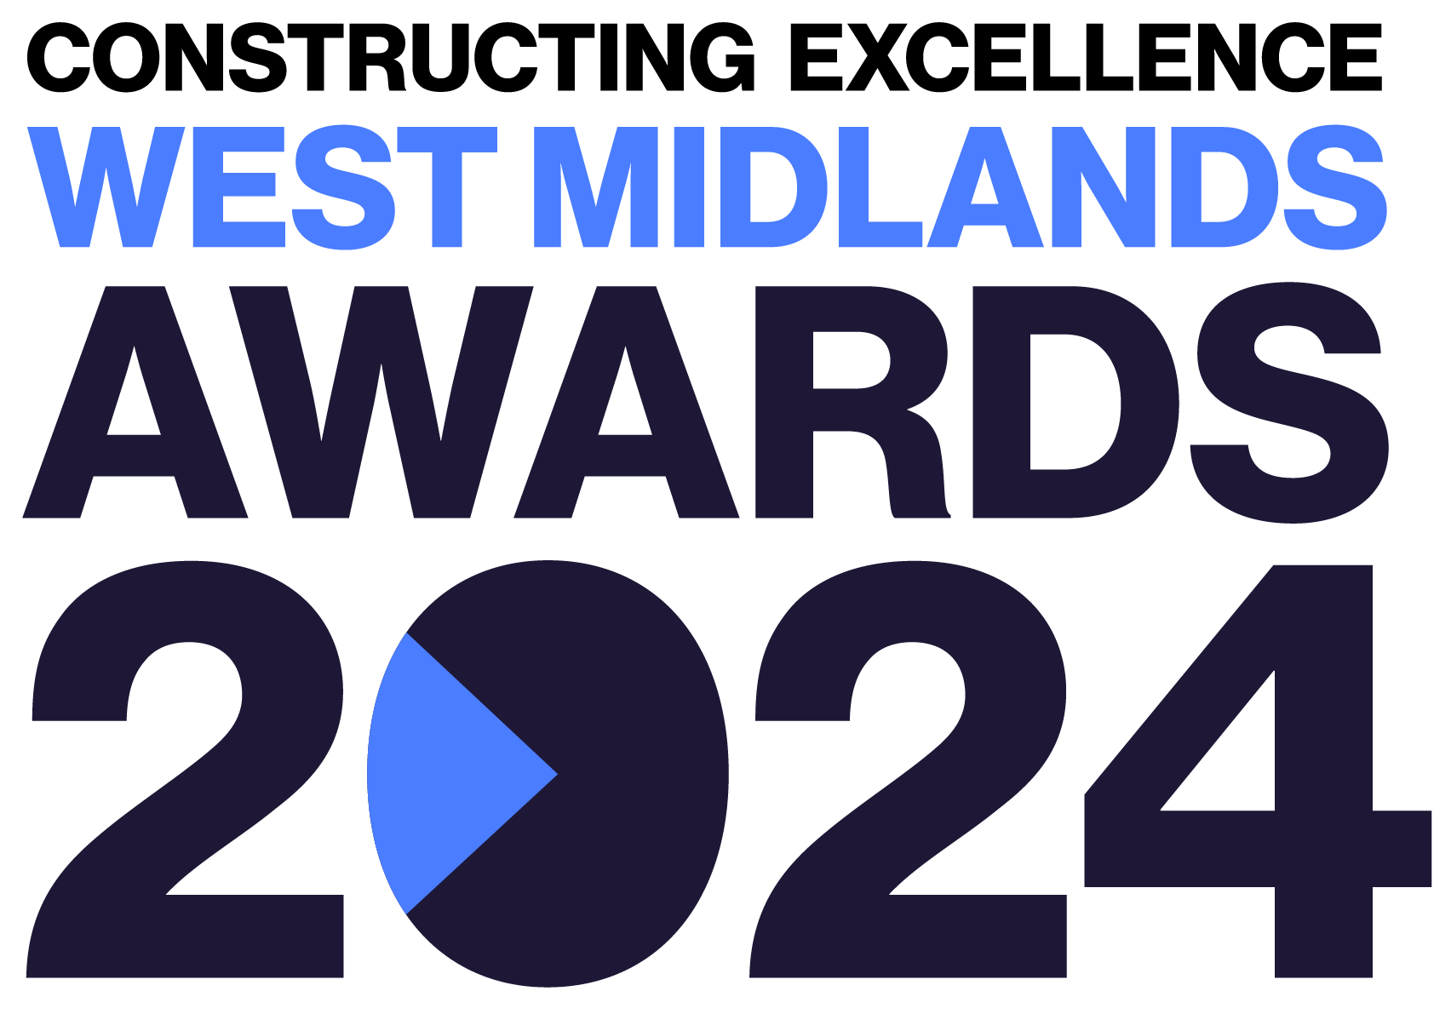
Climate Action
Constructing Excellence West Midlands Awards Entry Form

Category Description

All of us, within the construction industry and beyond, have a responsibility to deliver Climate Action. It is a key driver behind many innovative tools, techniques and processes and impacts everything we do. Excellence would like to celebrate those projects or organisations that seek to deliver a positive impact, or a reduced negative impact, on the natural environment and demonstrate whole life sustainability in their approach to construction. Successful applicants will exemplify the use of organisational culture, high quality design, effective procurement practices and innovative tools and techniques to provide improved environmental performance and outcomes.

Judges are looking for organisations, projects or initiatives that demonstrate:
- Readiness and progress to move towards zero emission vehicles and onsite plant.
- Commitment to reducing waste and transport to sites via improved logistics and MMC.
- Use of low carbon manufacture, transport, heating, lighting or processing solutions.
- Measurements or metrics to evaluate carbon and enable informed decision-making for carbon reduction.
- Use of circular economy.
- Use of innovation to reduce impact on the natural environment or enable positive environmental outcomes.
- Support of the development of low carbon materials and solutions.
- The team Must be based within the West Midlands

Entry Information:

To be included in your submission:

- ☐ Entry guidelines checked and adhered to – https://constructingexcellence.org.uk/awards-guidance/
- ☐ Completed entry form – low resolution images can be embedded to support your entry.
- ☐ Logos – for all key parties that should be recognised for the award (original .eps files).
- ☐ High resolution images (print quality) – up to 5 jpg files to be shared separately, not embedded.

Information included in your awards entry may be used by Constructing Excellence for Awards marketing purposes if the submission is successful.

Submissions must be received by: 9th Feb 2024

Completed entry forms and images should be sent to: westawards@cemidlands.org

Good luck!
The Constructing Excellence Team

Climate Action
Constructing Excellence West Midlands Awards Entry Form Project Details

Entry name
Region

*Maximum 70 characters (with spaces). The name will be on the award if successful*

Applicant’s contact details:

Name
Organisation
Email
Telephone
Address
Postcode

Organisations to be credited:

Please list the client related to this submission:

Client
Contact name
Email

Please list all organisations that should be credited in relation to this submission:

Organisation
Contact name
Email

Organisation
Contact name
Email

Organisation
Contact name
Email

Organisation
Contact name
Email

Organisation
Contact name
Email

Organisation
Contact name
Email

IMPORTANT: Logos – please supply HIGH QUALITY .eps or .jpeg logo files for all organisations mentioned.
These logos will be etched onto the glass trophies presented to winners.
Climate Action
Constructing Excellence Awards Entry Form Project Details

*Complete Section 1 if your submission is a project or Section 2 for an Initiative or Organisation

Project name
Project location
Project timescales or phase | Start date: | End date:
Project contract value
Type of work
(e.g. new build, refurb)
Type of client
(e.g. housing association, developer, gov. department)
Construction product
(e.g. school, housing, road)
Approx. m²

Organisation / Initiative Details

Organisation / initiative name
Location
Type of organisation (e.g. housing association, developer, government department, contractor, consultant)
Number of staff
Company turnover

Climate Action
Constructing Excellence Awards Entry Form Your Submission

- Provide a short overview (max. 250 words)

* Please provide a clear summary of the key aspects of your submission. This section will be used for marketing purposes. A clear and succinct answer ensures we showcase your project effectively. *

Guidance questions: Briefly describe the organisation/project - what makes this submission a winning entry? What are the three key facts that make this work stand out?
Three Winning Facts:
1.
2.
3.

- How did you systematically identify your key opportunities for Climate Action? What process or strategy was used to identify and prioritise the key issues to address? What were your top issues/challenges and why? (max. 250 words)

- What actions have been taken to make a shift towards zero emission vehicles and on-site plant? How have you dealt with connectivity with low carbon modes of transport? What provision was made to incorporate zero emission vehicles? Did the project require its partners to collect, report and improve vehicle emissions? (max. 250 words)

- How has waste and transport to sites been reduced? This may have been achieved via significantly better design, MMC, improved construction logistics plans or other strategies. How were these strategies employed and what measured benefits have been achieved? (max. 250 words)

- How has energy performance been enhanced? What tools and techniques were implemented to improve energy performance and reduce carbon through improved design, manufacture, installation and maintenance of all key elements that comprise your carbon footprint and climate impact? (max. 250 words)

- How is carbon being measured to support decision making to reduce carbon? What metrics/KPIs are being used? (max. 250 words)

- How has the selection of materials been influenced by circular economy? What consideration has been given to embodied carbon? (max. 250 words)

