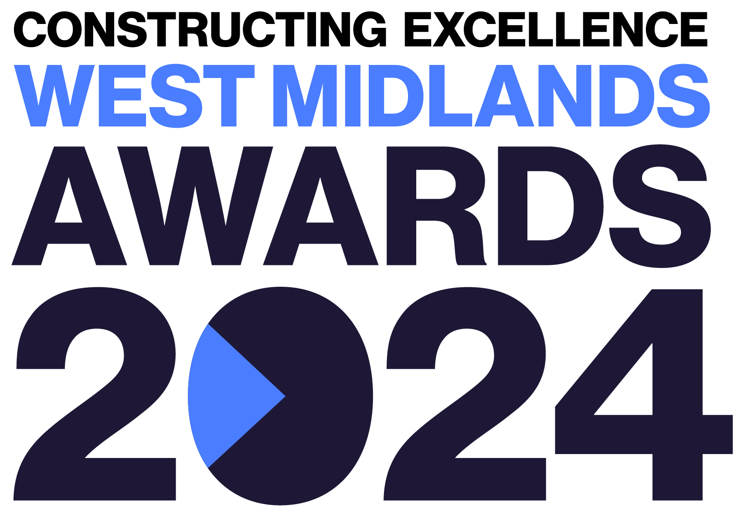
Building Project of the Year
Constructing Excellence West Midlands Awards Entry Form

Category Description

The Project of the Year category celebrates inspirational projects that deliver outstanding outcomes. We are looking for projects that exemplify the Constructing Excellence principles, which fully align with the collaborative work we are undertaking with the Construction Leadership Council. Projects should demonstrate the successful implementation of better ways of working and so help to provide a template for others to learn from.

Judges are looking for projects that demonstrate:
- Commercial practices that reward and incentivise the supply chain through collaborative procurement and delivery, and fair payment practices.
- High levels of productivity and a rigorous approach to measuring performance.
- A robust digital strategy, embedded within the project.
- A positive culture that embodies respect for people and an excellent approach to health safety and wellbeing.
- High levels of sustainability including demonstrable actions to cut carbon.
- Strong commitment to social value.
- A drive to change the culture of the industry.
- Adherence to the principles of the Building Safety Act and implementation of the Golden Thread
- Excellent levels of client satisfaction, delivering against client outcomes and expectations
- The project MUST be in the West Midlands

Entry Information:

To be included in your submission:

- ☐ Entry guidelines checked and adhered to – https://constructingexcellence.org.uk/awards-guidance/
- ☐ Completed entry form – low resolution images can be embedded to support your entry.
- ☐ Logos – for all key parties that should be recognised for the award (original .eps files).
- ☐ High resolution images (print quality) – up to 5 jpg files to be shared separately, not embedded.

Information included in your awards entry may be used by Constructing Excellence for Awards marketing purposes if the submission is successful.

Submissions must be received by: 9th February 2024

Completed entry forms and images should be sent to: westawards@cemidlands.org

Good luck!
The Constructing Excellence Team

Building Project of the Year
Constructing Excellence West Midlands Awards Entry Form Project Details

Entry name
Region

*Maximum 70 characters (with spaces). The name will be on the award if successful*

Applicant’s contact details:

Name
Organisation
Email
Telephone
Address
Postcode

Organisations to be credited:

Please list the client related to this submission:

Client
Contact name
Email

Please list all organisations that should be credited in relation to this submission:

Organisation
Contact name
Email

Organisation
Contact name
Email

Organisation
Contact name
Email

Organisation
Contact name
Email

Organisation
Contact name
Email

Organisation
Contact name
Email

IMPORTANT: Logos – please supply HIGH QUALITY .eps or .jpeg logo files for all organisations mentioned.
These logos will be etched onto the glass trophies presented to winners.
Building Project of the Year
Constructing Excellence Awards Entry Form Project Details

Project name
Project location
Project timescales or phase | Start date: | End date:
Project contract value
Type of work
(e.g. new build, refurb)
Type of client
(e.g. housing association, developer, gov. department)
Construction product
(e.g. school, housing, road)
Approx. m²

Building Project of the Year
Constructing Excellence Awards Entry Form Your Submission

- Provide a short overview of the project (max. 250 words)

* Please provide a clear summary of the key aspects of your submission. This section will be used for marketing purposes. A clear and succinct answer ensures we showcase your project effectively. *

Guidance questions: Briefly describe the project- what makes this project deserving of Building Project of the Year? What are the three key facts that make this project stand out?
Three Winning Facts:
1.
2.
3.

- Describe the delivery model for the project. What procurement strategy was used? How did you ensure the supply chain was properly incentivised? How did you ensure fair payment practices? (max. 250 words)

- How did you maintain and measure productivity? How did you use productivity tools on the project? What metrics did you use to measure performance? How successful were these measures? (max. 250 words)

- What approach did you take to ensuring a positive culture? How did you ensure and embed a positive culture? What was your approach to health, safety & wellbeing? How was equality, diversity and inclusion approached on the project? What metrics did you use to measure this? (max. 250 words)

- What digital strategy was employed on the project? How did you ensure an effective use of digital technologies? What benefits did this approach bring? How were benefits measured? (max. 250 words)

- Describe your approach to sustainability? How did you embed sustainability in the project? What steps did you take to achieve this? How did you measure it? (max. 250 words)

- How was social value implemented? How did you embed social value on the project? What steps did you take to achieve this? How did you measure it? (max. 250 words)

- How does the project align with the Building Safety Act? Describe how you have approached the Building Safety act on the project? How did you approach the Golden Thread? (max. 250 words)

- How was the client involved in the project and did the project deliver their defined anticipated outcomes? How did you ensure the project was aligned with client expectations? How was client satisfaction measured? Provide evidence that the client is pleased with the end result? (max. 250 words)

