GIRI Update for Meeting 13.07.21
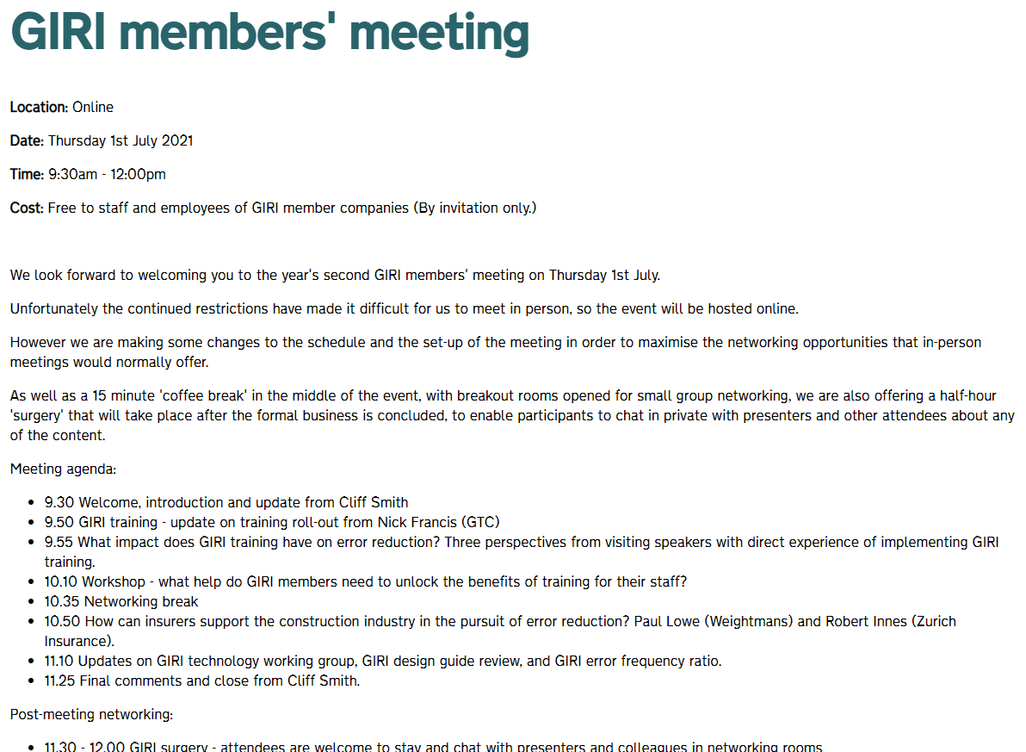

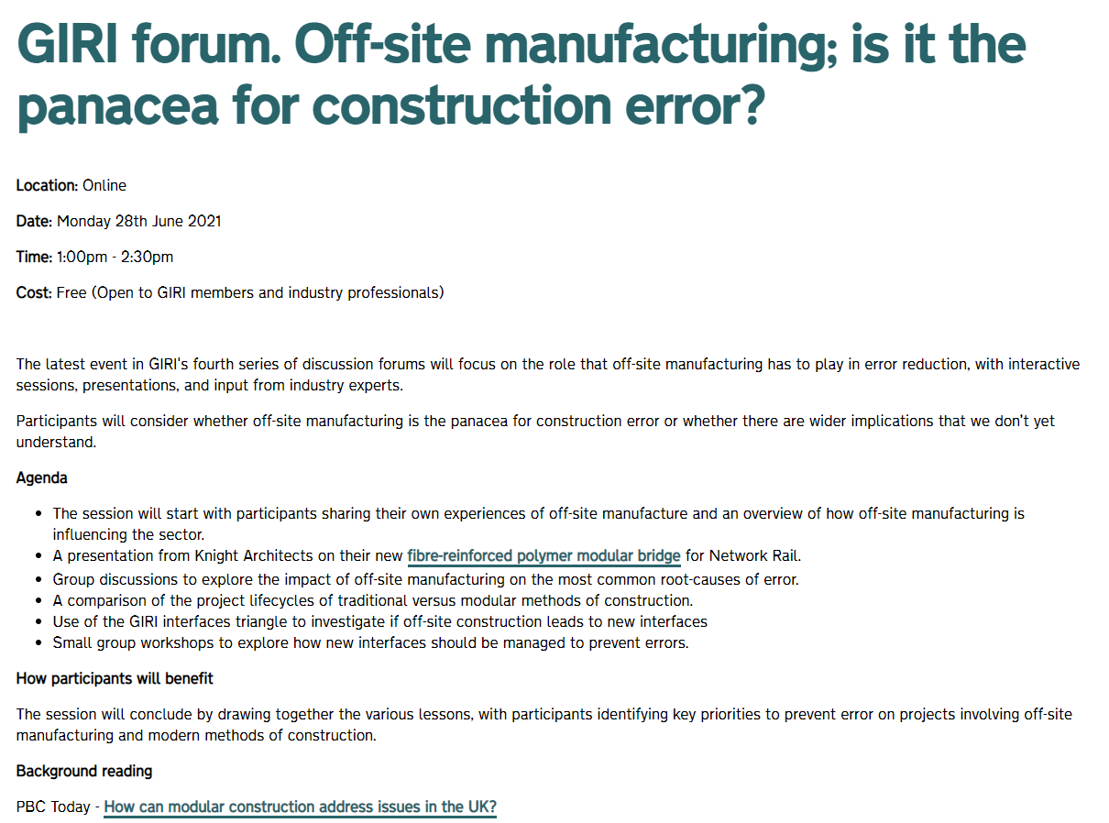
GIRI Forum: Off-site manufacturing; is it the panacea for construction error? - YouTube
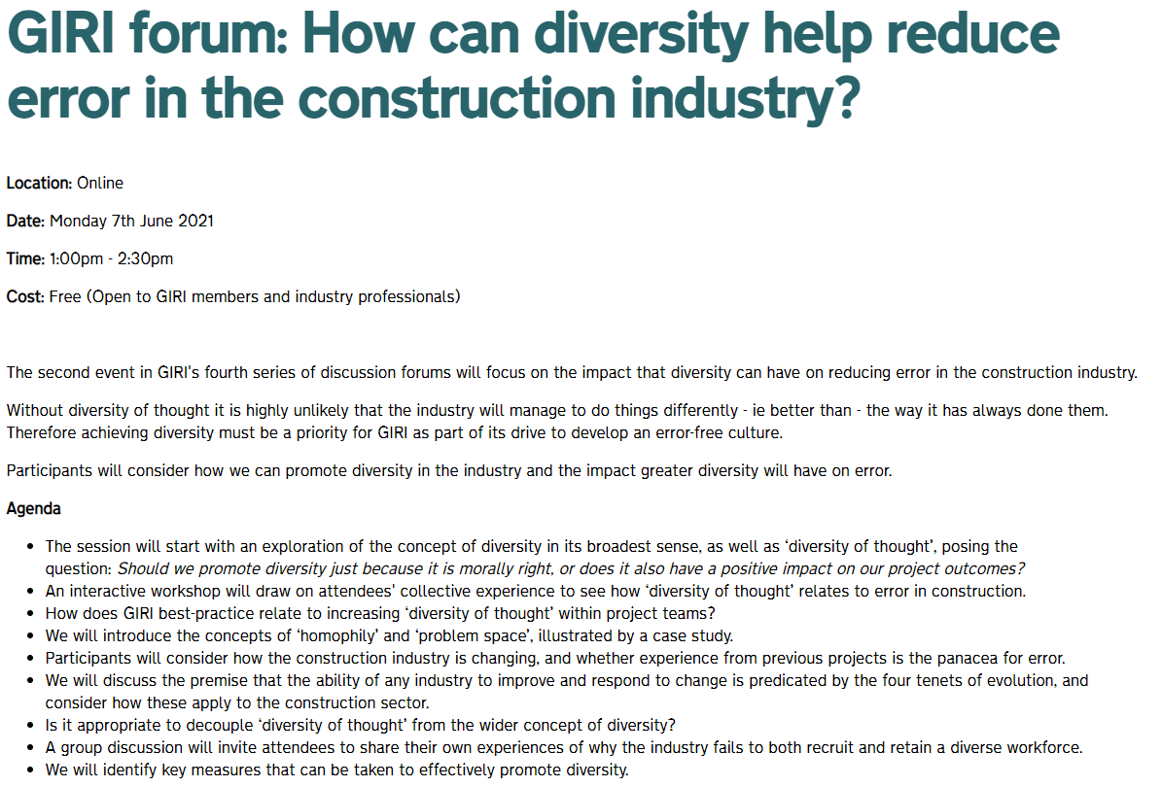
GIRI forum: How can diversity help reduce error in the construction industry? - YouTube

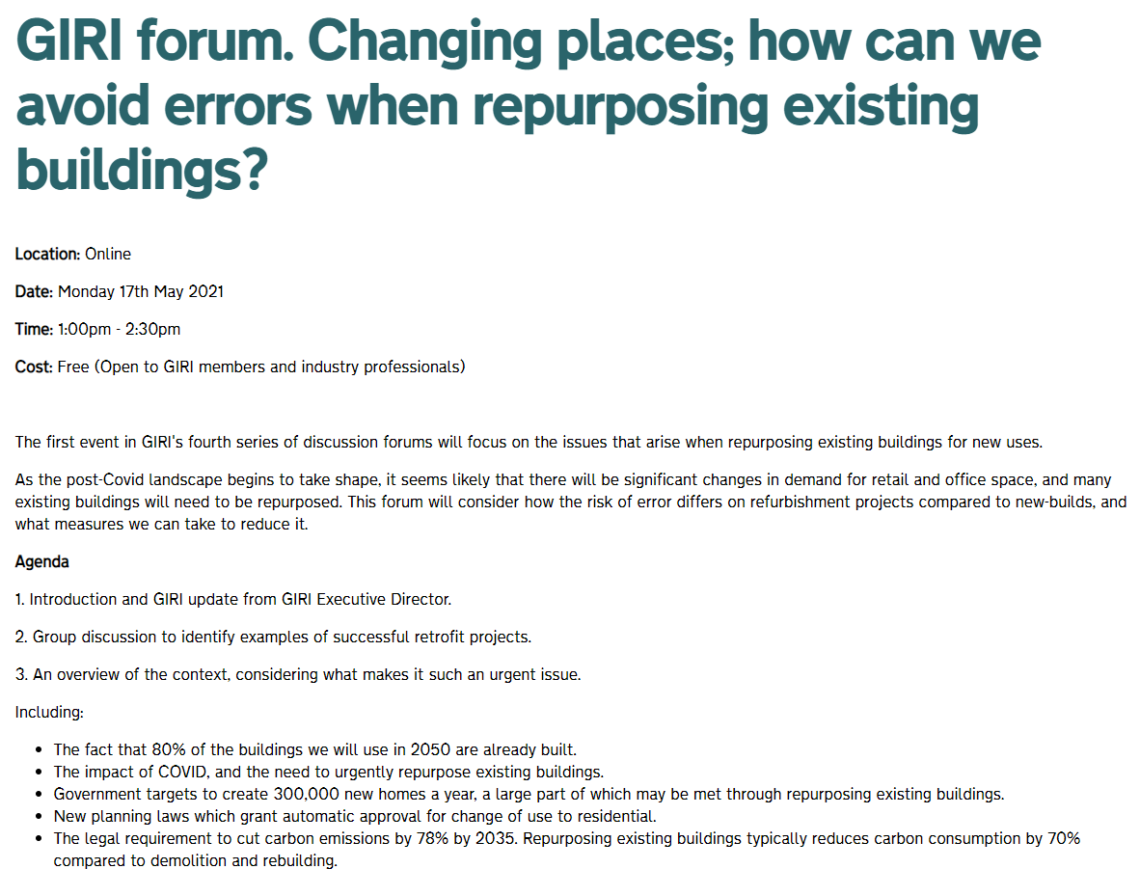
GIRI forum. Changing places; how can we avoid errors when repurposing existing buildings? - YouTube

